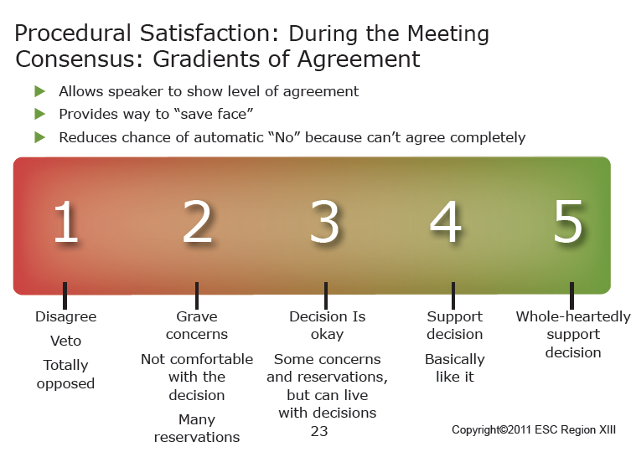

Option 1: Consensus Language using the Gradients of Agreement Poster and Cards or Post-Its or Hand Signals:
“The recommendation on the table is: _________________________________________________
Indicate your level of agreement by using the gradients of agreement cards.
Remember a rating of 3, 4, or 5 indicates you can ‘live with’ the recommendation or, all the way to 5, you are ‘very happy’ with the recommendation.
We will discuss ratings of 1 or 2 and then rate again.”

Option 2: Consensus Language WITHOUT Poster or Cards:
“The recommendation on the table is: __________________________________________________
Talk about your level of agreement with the recommendation.
Talk about whether the recommendation is something you can whole-heartedly support or can live with or have concerns about.
If you have concerns, let’s discuss more fully.”

