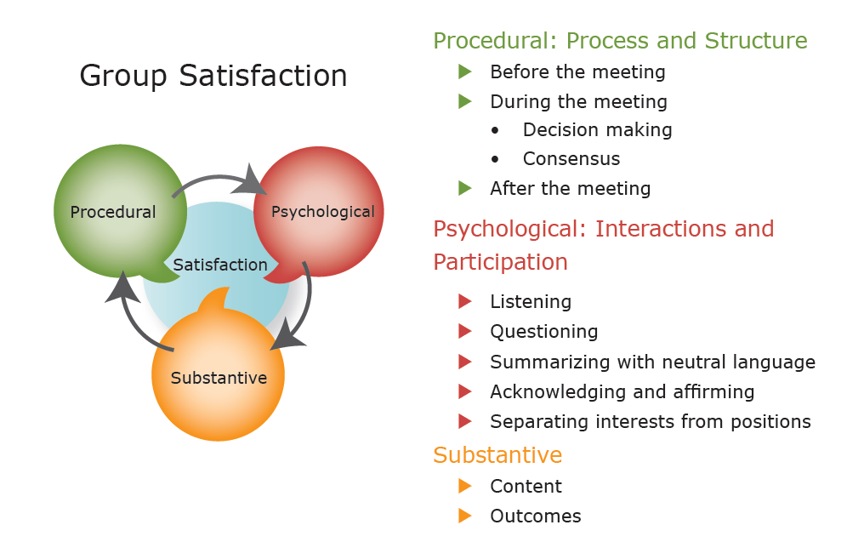

Correct Application of Law

Quality Documents

Designed to Promote Student Progress