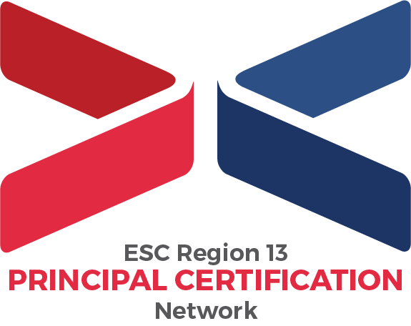
Early Bird 13 Scholarship Application
Instructions:
- Deadline: October 29, 2021 5PM CST
- Award: Scholarship recipient will receive $1300 off from $6000 program fees total.
- Required Steps:
  - Pre-requisite: Complete online application including payment of application fee.
  - Download this scholarship application document and complete the scholarship application cover page information below. Save this document as “EARLYBIRD13CP_LAST NAME”.
  - Complete all essay responses on a separate Word document. Each essay question’s response should be 12 pt. Times New Roman font, single-spaced, minimum of 250 words. Save all responses on one document as “EARLYBIRD13ER_LAST NAME”.
  - Access Recommendation Letter from your intended Campus Principal Mentor. Save your Reference Letter as “EARLYBIRD13RF_LAST NAME”.
  - Submit completed scholarship application cover page, essay responses, and Principal Mentor Recommendation Letter together to Leadership@esc13.txed.net by October 29, 2021 5PM CST.

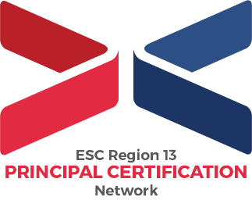
Early Bird 13 Scholarship Application

Cover Page Application Information:
Full Name (as listen in online application)
Preferred Phone Number
Preferred Email Address
Full Name, Location, Phone Number, and Email Address of Campus Principal Mentor (from Recommendation Letter)

Essay Questions:
Texas has prioritized the focus of principal as instructional leader. In response to the questions below, you’ll explore how your participation and completion of PCN will support this goal for Texas leadership.

- A) Why do you want to lead a school?
- How will you as an invested leader transition into becoming a great principal?
Note: If you’re seeking Principal certification for a leadership role supporting Campus Principals, tailor your response to address this connection.

- Leadership positions are time-consuming and full of responsibility. Training for these roles through Region 13’s PCN while working full-time in your current role, as well as constant changes due to the pandemic, may feel overwhelming. How do you intend to practice effective time management and social-emotional wellness strategies in order to ensure you are successful throughout this process?

- Why should you receive this PCN scholarship versus one of your peers?

